# Pressure Tank Report

This report provides an explanation of the calculations and measurements related to the range performance of the pressure tank gun currently under development.

# Prerequisite to the report

We are developing a water gun designed to achieve a minimum range of six meters. To meet this requirement, a commercial pump has been acquired and is currently being tested by Tolga and Nikita. In parallel, we are exploring alternative propulsion methods, including a reverse bottle rocket concept, where the bottle remains stationary while the water is expelled.

Our target is to pressurize the bottles to 50 PSI, which, based on Radu’s calculations, would result in an estimated exit velocity of 22 m/s. These calculations can be found below:

Et billede, der indeholder tekst, håndskrift, blæk/sværte, papir

Indhold genereret af kunstig intelligens kan være forkert.

# First and second try

In our initial attempt, we constructed the system similarly to a conventional bottle rocket, where components such as the valve and the one-way pressurization valve were glued directly to the bottle.

Below are images of the setup, along with a brief explanation of why this approach was unsuccessful:

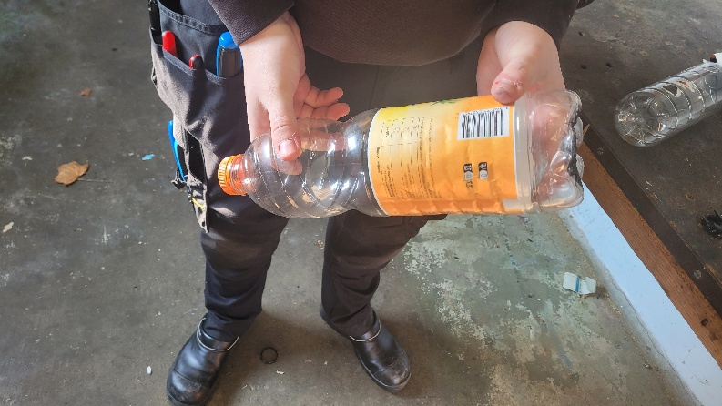Et billede, der indeholder maskine, Metalarbejde, bore/bor, Maskinværktøj

Indhold genereret af kunstig intelligens kan være forkert.

Et billede, der indeholder værktøj, person, Maskinværktøj, jord

Indhold genereret af kunstig intelligens kan være forkert.

The concept was sound, but the execution revealed some issues. The assembly was able to withstand pressure up to approximately 10 PSI; however, beyond that point, the glue securing the release valve failed, causing it to detach from the cap.

This failure occurred because the adhesive does not bond effectively to "fatty plastics" such as polypropylene (PP), which was used for the valve components. In contrast, polyethylene terephthalate (PET), which makes up the main body of the bottle, is not considered a fatty plastic and allowed for a stronger adhesive bond. As a result, the one-way valve held securely, while the release valve did not.

To address this issue, we redesigned the system so that all glued components were attached only to the PET bottle material. The revised design is shown below:

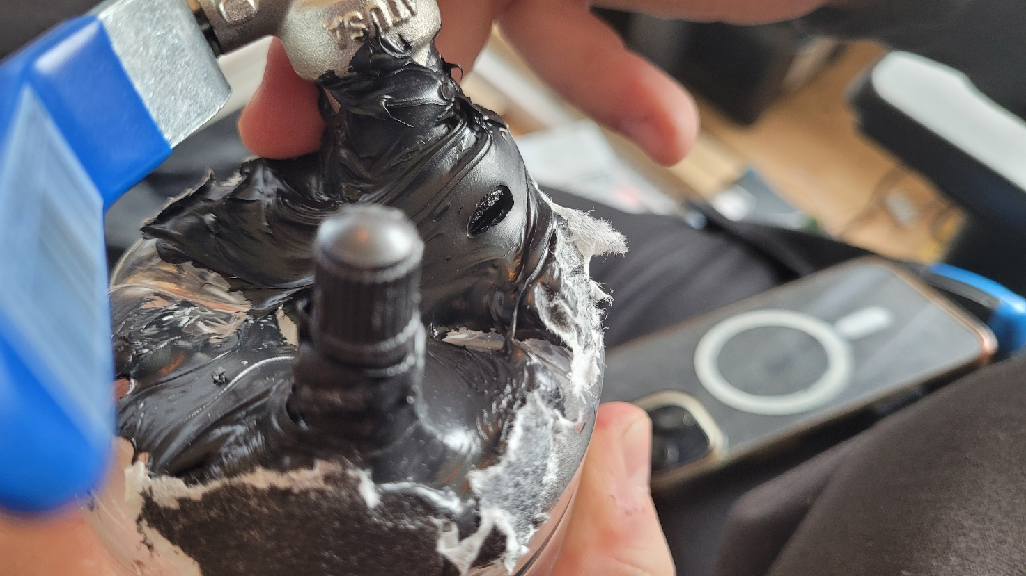

Et billede, der indeholder person, indendørs, blender, Laboratorieudstyr

Indhold genereret af kunstig intelligens kan være forkert.

This revised approach showed slight improvement, managing to withstand up to 12 PSI before the glue once again failed, resulting in a sudden release of water. While this was a step forward, it remained far from a reliable solution.

To explore more robust alternatives, we began brainstorming unconventional solutions. One idea involved fabricating a custom steel pressure tank through welding. However, commercially available steel tanks were generally too heavy—often exceeding our 11 kg weight limit—and featured unnecessarily large capacities for our intended use.

As a result, we began investigating alternative types of pressure tanks:

# Pressure tanks made from PVC pipe.

We drew inspiration from a variety of sources, focusing in particular on projects where others had successfully stored between 80 and 120 PSI in air cannons—systems with designs conceptually similar to our own. These examples provided valuable insights into feasible construction methods and material choices.

The primary reference we followed was a YouTube video that served as a practical guide for our design approach, which can be found here:

Et billede, der indeholder cylinder, indendørs, lampe, gulv

Indhold genereret af kunstig intelligens kan være forkert.

<https://www.youtube.com/watch?v=NvH9WHNxvj8>

Unfortunately, we were unable to construct this type of pressure tank before identifying new and potentially more effective design alternatives. Additionally, due to the university’s strict safety regulations—particularly those concerning the use of pressurized components—we were not permitted to glue end caps onto the pressure tubes, as this posed a risk of failure and potential injury.

As a result, we decided to continue exploring alternative solutions that align with both our performance requirements and safety constraints.

# 3D printed tank

Initially, we did not believe a 3D-printed pressure tank would be a viable option. In general, 3D-printed components are not considered watertight—or gas-tight—due to the presence of small gaps and layer imperfections inherent in the printing process. As a result, we dismissed this solution early on.

However, our perspective changed after discovering the following video, which demonstrated a successful implementation of a functional 3D-printed pressure vessel:

Et billede, der indeholder tekst, skærmbillede, software, Multimediesoftware

Indhold genereret af kunstig intelligens kan være forkert.

<https://www.youtube.com/watch?v=ZB6VbkeYrkw>

The video demonstrated that there is indeed significant potential for a 3D-printed pressure vessel to function effectively. However, one of the key limitations highlighted in the project was the inability to achieve a fully leak-proof design.

Based on these findings, we began investigating alternative methods and materials that could address this issue while still allowing us to pursue the 3D-printed tank concept.

Et billede, der indeholder apparat/anordning, Måleinstrument, måler, jord

Indhold genereret af kunstig intelligens kan være forkert.

The video showcased a similar pressure tank design that achieved a leak-free seal and was fabricated using ABS plastic rather than PLA. The tank was also vapor-smoothed with acetone to improve surface integrity and sealing. While vapor smoothing using a controlled acetone chamber is not feasible within school facilities, a more practical approach—brushing acetone directly onto the surface—appears to be a workable alternative.

To evaluate this approach, we began by printing a small-scale prototype. Tobias 3D printed the initial model using his personal printer and mounted the necessary components, including a one-way valve and a release valve. Despite noticeable leakage, the design was able to hold pressure up to 100 PSI. Further testing beyond this point was avoided for safety reasons.

Following this initial success, we chose to print an improved version with increased structural integrity. The original print featured only two outer walls, a 30% infill, and two inner walls, which left us with limited confidence in its durability during higher-pressure testing. To address this, we reprinted the tank with a total of twelve perimeters (walls), greatly enhancing its ability to withstand internal pressure and improving its watertightness.

Although we do not believe twelve walls will be necessary for the final design—based on references from YouTube demonstrations showing sufficient performance with as few as four to six walls—we opted for a highly reinforced version during the testing phase. The rationale behind this decision was to prevent premature leaks or structural failures before implementing a proper safety valve system. This safety valve will be essential for releasing pressure in case it exceeds the design threshold. Until such a system is integrated, it is important to maintain a conservative design with a sufficient number of walls to ensure safe and reliable pressure testing

Introduction of Barometer

For the final product, our goal is to reproduce a consistent internal pressure without relying on visual inspection of the compressor’s built-in barometer, as this would require manual intervention. To automate and monitor the system more effectively, we aim to integrate a pressure sensor (barometer) directly into the tank.

Incorporating electronics into a sealed pressure vessel presents a significant challenge, particularly in maintaining structural integrity while allowing for electrical wiring. Wireless solutions were considered, but due to concerns regarding their reliability—especially in critical testing or demonstration scenarios—we opted for a wired approach to ensure consistent performance.

To accommodate this, we have designed a small square access port in the tank wall, which can be sealed using a removable end cap. The cap is secured with eight M3 bolts, each providing a theoretical pullout strength of 1304 N per thread. This configuration is intended to maintain a tight seal under pressure while still allowing for sensor installation and wire routing in a controlled and serviceable manner.

Et billede, der indeholder tekst, skærmbillede, Font/skrifttype, nummer/tal

Indhold genereret af kunstig intelligens kan være forkert.

Based on the calculated pullout strength of the threaded inserts, the lid assembly is theoretically capable of withstanding internal pressures exceeding 1600 PSI. This high pressure capacity is due to the use of threaded heat-set inserts in the PLA body, which offer significantly better thread strength and reusability compared to directly 3D printed threads. These inserts allow the cap to be securely mounted and removed repeatedly without degrading the structural integrity of the connection.

However, it is important to note that while the calculated values suggest high mechanical resilience, the actual performance is limited by the material properties of the lid itself. Since the lid is printed in plastic, it is likely to deform or fail well before reaching the theoretical pressure limit. Nonetheless, these calculations provide a useful theoretical baseline, indicating that the overall design is likely sufficient for our target operating range.

To achieve a proper seal between the cap and the pressure vessel, we plan to manufacture a custom 3D-printed gasket using TPU (thermoplastic polyurethane). Fortunately, TPU filament is available for in-house use, allowing immediate production without reliance on the university’s 3D printing lab schedule.

This "lid gasket," as we will refer to it moving forward, will initially be printed using standard 80A TPU, which is one of the softest commercially available grades. In parallel, we have also requested assistance from Olga—who specializes in advanced 3D printing workflows—to fabricate a version using a silicone-like pellet-based material available in the university’s lab, which may offer improved sealing properties.

For the lid material, we intend to transition from PLA to PETG reinforced with carbon fiber. This material offers increased stiffness, which is essential to prevent bending or deformation in areas not supported by bolts. However, we will continue initial tests using PLA, particularly in fully dense (100% infill) configurations, before making final material decisions based on actual performance data.

Ultimately, this design iteration proved unsuccessful. The following section provides a detailed breakdown of its shortcomings:

Barometer

Initially, the pressure sensor appeared suitable for our application, as the specification sheet listed a pressure range from 0 to 1100 MPa. This would have far exceeded our operational requirements. However, upon closer inspection, it became clear that the unit was in fact specified in hectopascals (hPa), not megapascals (MPa). This meant the sensor's actual maximum measurable pressure was approximately 1100 hPa, or roughly 15.9 PSI.

Given that this value falls well below the pressures we intend to operate with, the sensor was deemed unsuitable for our design. As a result, we decided to abandon the use of an electronic pressure sensor altogether and instead rely on a mechanical pressure relief valve to regulate internal pressure.

This shift in approach later proved to be beneficial, particularly when working with compressed air systems, where pressure control and fail-safety are critical.

Tank lid design

In the end, introducing a hole into the pressure tank presents a significant compromise in both safety and long-term reliability. While certain commercial pressure vessels are designed with lids or integrated sealing mechanisms, maintaining a completely sealed structure is generally preferable for sustained performance and structural integrity.

For this reason, we concluded that embedding a pressure sensor directly inside the tank is not the optimal solution. Instead, a more reliable and modular approach involves integrating the pressure reading system into the outlet assembly, specifically within the 1/2-inch tube fitting system. This configuration eliminates the need to modify or reprint the pressure vessel for each revision and allows for greater adaptability across different testing scenarios and use cases.

This modular strategy not only simplifies the overall design and reduces failure points but also enables easier maintenance and customization without compromising the structural integrity of the tank itself.

# Redesign to be better to 3D print.

We had to redesign the 3D printed pressure tank to make sure that we didn’t have too many failures due to printing stopping/failures. Therefore we made a new design with walls that where 45* slanted on the inside, this was to make sure that we it didn’t fall on itself.

Et billede, der indeholder design

Indhold genereret af kunstig intelligens kan være forkert.therefore as you can see in the picture we will have a bit thicker wall at the “corners” of the pressure tank, this will make no difference in the strength of the pressure tank, but will have an effect on the internal volume of the vessel.

We are not worried that this was effecting anything, so we moved forward and had successful prints.

We then calculated the maximum pressures that this vessel could handle.

# Calculating Maximum pressure

**4.1 Maximum Internal Pressure Estimation Based on Material Strength**

To determine the safe working pressure of the cylindrical vessel, we apply classical thin-walled pressure vessel theory. The objective is to identify the maximum internal pressure the structure can withstand without exceeding the material's tensile strength, accounting for anisotropic mechanical properties introduced by the 3D printing process.

**Geometrical Parameters:**

- Inner radius: r = 90 mm = 0.09 m

- Wall thickness: t = 5 mm = 0.005 m

**4.1.1 Hoop Stress (Circumferential Direction – XY Plane)**

The hoop stress represents the stress experienced along the circumference of the cylindrical wall due to internal pressure. For a thin-walled vessel, it is given by:

***σₕ = (P × r) / t → P = (σₕ × t) / r***

Assuming the printed material achieves a tensile strength of approximately 50 MPa in the XY (hoop) direction:

P = (50 × 10⁶ × 0.005) / 0.09 = 2.78 × 10⁶ Pa = 2.78 MPa

This corresponds to an approximate internal pressure of 2.78 MPa, or 403 PSI. This value represents the theoretical maximum pressure before failure due to hoop stress.

**4.1.2 Longitudinal Stress (Z Axis – Layer Direction)**

Due to the layer-by-layer nature of additive manufacturing, tensile strength in the Z direction is significantly reduced compared to the XY plane. For safety and based on empirical estimates, the tensile strength along the Z axis is assumed to be approximately 15 MPa.

The longitudinal stress for a cylindrical pressure vessel is given by:

***σₗ = (P × r) / (2 × t) → P = (2 × σₗ × t) / r***

P = (2 × 15 × 10⁶ × 0.005) / 0.09 = 1.67 × 10⁶ Pa = 1.67 MPa

This corresponds to approximately 1.67 MPa, or 242 PSI.

**Conclusion**

While the circumferential (hoop) stress limit suggests a maximum pressure of 2.78 MPa, the more critical failure mode lies along the longitudinal axis due to reduced tensile strength in the Z direction. Therefore, the safe maximum internal pressure for this vessel should be considered as 1.67 MPa, unless post-processing or reinforcement is used to improve layer adhesion strength.

As we will not go over the safety limit of 9Bar or 0.9MPa, this would be okay, and we can now go ahead with more testing.

# Setting up a test bench

After finally having producing a workable and usable pressure vessel, now comes to producing a way to get pressure into, and out of the pressure vessel. Getting pressure in was rather easy, using a normal 1 way valve for air in car tires, because of its cheapness, and also having a rather high working pressure (up to 8 bar if you get the correct ones) and its design philosophy being so easy (only needing a 12.5mm hole to work) it was a obvious choice to make.

The other side I put in ½ inch thread, this would make sure that our pressure vessel would work with standard size fittings from plumbing, this would greatly reduce the amount of money needed to finance the testing, and also is a very nice standartisation when it comes to the actual Magnetic solenoid valve. This would make sure that we could open it electronically instead of with a manual ball valve.

This would connect directly to a T piece, that would interconnect the pressure tank, the safety valve( more about this in a bit) and the exhaust solenoid valve.

The safety valve was a bit of a pain in the ass to get, normally safety valves will need somewhere to vent (this also does this) but because it has an o-ring to make it water proof, we didn’t just want to leave it open and shoot out that bit when or if it needs to vent. Therefore we installed the ball valve that we got for testing on that side.

**This is highly dangerous because if that valve is not open when it needs to vent it will not do its job, this need to be changed if this design has to be used for anything on the regular. This is not safe to leave to people remembering it.**

But, because this is just a prototype, this will be more than plenty at first.

The models looks something close to this. We have not modeled the safety valve and the ball valve, simply because we are running out of time before we have to hand everything in, but here you can see the assembly of the full thing.

Et billede, der indeholder cylinder, fløjte/pibe/rør, måler

Indhold genereret af kunstig intelligens kan være forkert.

Using simple plumbing fittings and pipe will decrease the fluid flow through the pressure tank assembly, but just using more pressure would eliminate this issue.

Using this assembly, we managed to get some very good results, more than what was expected from the calculations.

Shooting over 11meters at just 4.5 Bar

And over 15meters at 7bar. This shows a huge improvement over the bought pump that we have. But also shines its most